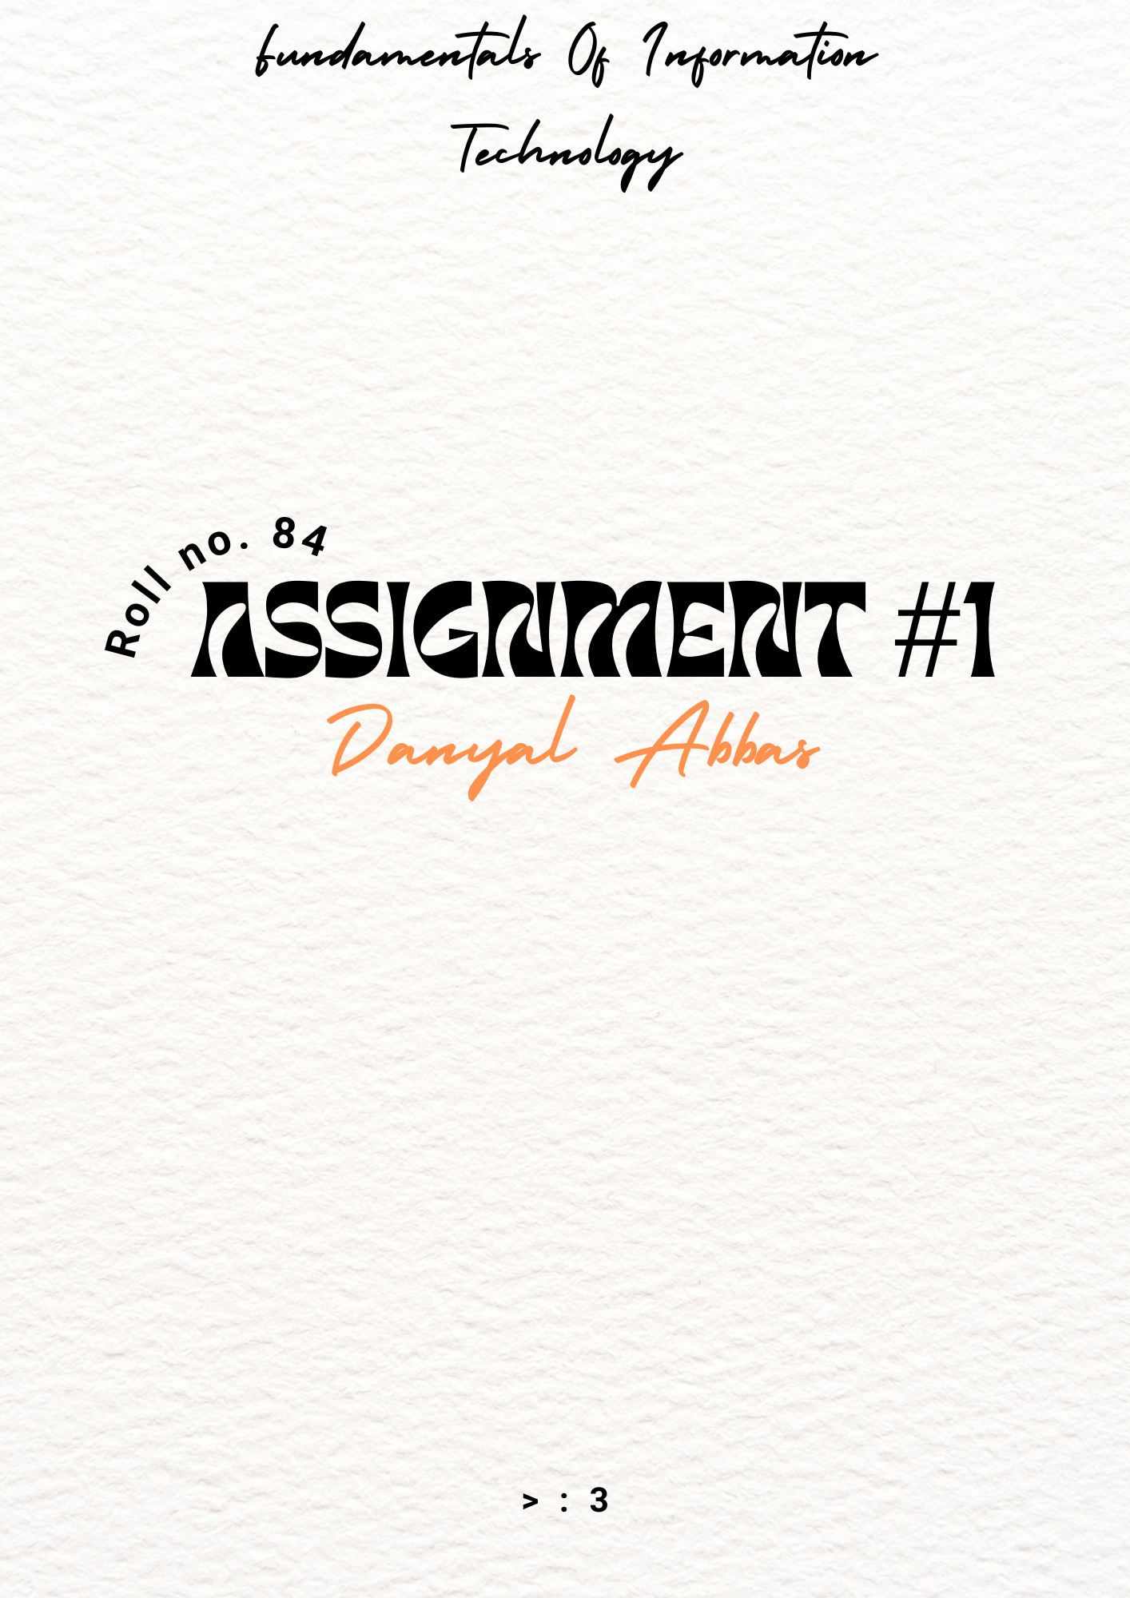

# **Machine Learning**

#### 1. **Technology Type:**

**Machine Learning (ML)** is a subset of artificial intelligence (AI) that enables computers to learn and make decisions without being explicitly programmed. Instead of following strict pre-coded rules, ML algorithms analyze data, identify patterns, and improve their performance over time. This technology has widespread applications across industries, including healthcare, finance, e-commerce, and personal computing.

#### 2. **Provide Detail:**

* Machine Learning is used in each part of our lives nowadays, be it in the streaming services we use as **Collaborative Filtering.**
* Machine Learning can also be used to help people with disabilities and make their lives better and easier, one example of that is Sign Language Translator.

#### 3. **Describe Integration:**

* **On-Device AI and ML**: Many devices now have dedicated hardware components for machine learning, allowing processing to happen directly on the device instead of relying on cloud computing. For example, Apple’s **Neural Engine** (in the **M1 chip**) and Google’s **Tensor.**
* These ML models are integrated into daily use without users realizing it. The seamless operation of features like **voice recognition**, **image enhancement**, and **smart suggestions** are all driven by on-device machine learning.

#### 4. **Architecture/Design:**

* There are various different libraries that help us utilize Machine Learning and Deep Learning into being. Most of popular of them are TensorFlow, Sci-kit learn etc.
* Machine Learning depends upon different mathematical algorithms, training and testing set and making machine act somehow like a human

#### **5. Project Utilizing Machine Learning (SignSpeak):**

I have also utilized Machine Learning to do my part to help people in need, Here’s a Project I made with my colleague utilizing Machine Learning/Deep Learning that translated Sign Language into English Language

**Github Repository:** [**https://github.com/DanyalAbbas/SignSpeak**](https://github.com/DanyalAbbas/SignSpeak)  
**Video Documentation:** [**https://www.linkedin.com/DanyalAbbas/video**](https://www.linkedin.com/feed/update/urn:li:activity:7167151574987825154/)

# **E-Commerce**

#### 1. **Technology Type:**

* **E-commerce** refers to the buying and selling of goods and services through online platforms. It encompasses online shopping, digital payments, and customer service tools. E-commerce platforms use digital storefronts, secure payment gateways, and delivery logistics to facilitate seamless transactions.
* It represents a shift from traditional retail to online, enabled by digital tools and internet connectivity.

#### 2. **Provide Detail:**

* I frequently use **Daraz.pk** and **Alibaba** for purchasing products, and I rely on **SadaPay** and **Jazzcash** for secure payments. Additionally, I manage subscriptions to services like **Amazon Prime** and **Spotify**, which fall under the e-commerce ecosystem.
* Websites like **Z2U** and **Olx** also serve as marketplaces where I explore and buy niche products from smaller sellers.

#### 3. **Describe Integration:**

* E-commerce platforms like **Daraz** have their own apps, but I typically access them through the browser, with my account information synced across devices.
* Shopping apps like **Amazon** leverage the Pixel’s **5G connectivity** for fast product searches and quick loading times, enhancing the shopping experience.

#### 4. **Architecture/Design:**

* E-commerce platforms rely on **cloud infrastructure** to manage massive amounts of data, transactions, and user activity. Amazon, for example, uses **Amazon Web Services (AWS)** to host its platform and ensure high availability and scalability for millions of users.
* **E-commerce platforms** are designed with secure **end-to-end encryption** for payment transactions. This ensures that sensitive information, such as credit card details, is kept secure throughout the purchase process.